EXHIBITOR PACKAGE
2023
(Updated January 28)

About Us | Kelowna ComiCon (KCC) is entering its sixth year running. At KCC we are dedicated to creating awareness of, and promoting an appreciation for, pop culture fandoms. We have seen growth every year in our attendance, both from ticket holders and exhibitors, and expect this year to be even larger. With inclusion of all different fandoms (comics, sci-fi, anime, and video games, just to name a few), our convention welcomes everyone!  With the health and safety of our staff, attendees, guests, and exhibitors in mind, we will be adhering to a no-tolerance policy in regards to the current Provincial and Regional mandates. This means that as the regulations for events change, we will adjust our event capabilities accordingly.  We have outlined what our maximum expected layout looks like in this package in the hopes that we will return to previous event capacities. This will include attendance information, booth information, pricing and add-ons. All current regulations, future changes and up to date layouts can be found at www.kelownacomicon.com/post/2022COVID  Whether you are interested in purchasing a booth from us or have questions, our team would be happy to hear from you.  Sincerely,  Your Kelowna ComiCon Team  info@kelownacomicon.com

Table of Contents | About Us | 1
 | - Exhibitor Booth Pricing | 2
 | - Exhibitor Booth Details | 3
 | - Venue Hours of Operation | 4
 | - Capital News Centre Layout | 4
 | - Venue Space Layout | 7
 | - Exhibitor Food | 8
 | - Attendance / Traffic | 9
 | - Exhibitor Application | 9
 | - Exhibitor Contract | 10

- Exhibitor Booth Pricing

- Exhibitor Badges include access to all public areas of the event
- GST and payment processing fees are not included in any pricing
- All Passes are subject to Kelowna ComiCon General Policies
- Exhibitors will need to supply their own carts in order to transport items from the loading bays to the Exhibitor’s booth(s) during the setup and teardown hours
- Exhibitors are required to carry items by hand to their booths during ‘Open’ hours
Booth Sizes & Add-Ons | Cost (ea)
Standard Booth  (10’x10’ space c/w two (2) Exhibitor Badges, one (1) 8’ Table, two (2) Chairs) | $325+tax
Double Booth  (10'x20' space c/w four (4) Exhibitor Badges, two (2) 8' Tables, four (4) Chairs) | $550 +tax
Corner Booth  (10'x10' c/w two (2) Exhibitor Badges, two (2) 8' Table, two (2) Chairs) | $375 +tax
Endcap Booth  (10'x20' c/w four (4) Exhibitor Badges, four (4) 8' Table, four (4) Chairs) | $625 +tax
Power Access for Booth(s) | $50 +tax
6’ or 8’ Additional Table(s) | $15 +tax
Additional Chair(s) | $5 +tax

- Exhibitor Booth Details

- Custom booth sizes can be arranged by contacting us at info@kelownacomicon.com
- All booths come with 8’ high pipe and drape separating different booth spaces
- For 2023, Internet will be supplied at the cost of Kelowna ComiCon
- Power will be an additional cost to Exhibitor's of $50.00 +tax per application
- Four (4) types of booth options are available for rental (see diagrams below):
Standard Booth  (10’x10’ space c/w two (2) Exhibitor Badges, one (1) 8’ Table, two (2) Chairs) | 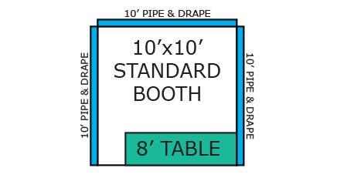
Double Booth  (10'x20' space c/w four (4) Exhibitor Badges, two (2) 8' Tables, two (2) Chairs) | 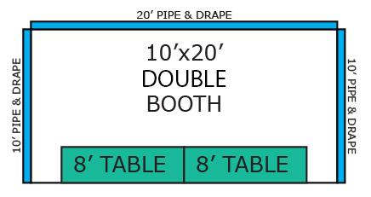
Corner Booth  (10'x10' c/w two (2) Exhibitor Badges, two (2) 8' Table, two (2) Chairs) | 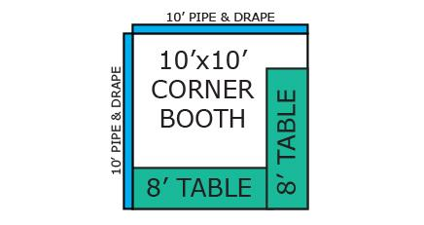
Endcap Booth  (10'x20' c/w four (4) Exhibitor Badges, four (4) 8' Table, two (2) Chairs) | 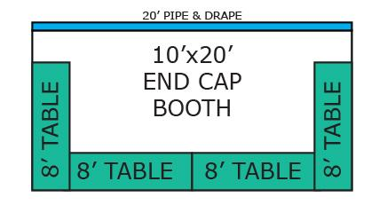

- Venue Hours of Operation

- Venue Hours are Accurate and May Not Reflect the Hours Listed by the Capital News Centre
Friday  August 18, 2023 | 11:00am - 4:30pm | KCC Team Begins Event Setup
 | 4:30pm - 10:00pm  5:30pm - 10:00pm | Vendors/Exhibitors Event Setup  Artists Event Setup
Saturday  August 19, 2023 | 7:00am - 9:00am | Exhibitor Preparation Time/ Event Setup
 | 9:00am - 10:00am | VIP & Premium Early Access
 | 10:00am - 6:00pm | KCC Main Hours of Operation
 | 6:00pm - 7:00pm | Exhibitor Preparation Time
Sunday  August 20, 2023 | 7:00am - 9:00am | Exhibitor Preparation Time
 | 9:00am - 10:00am | VIP & Premium Early Access
 | 10:00am - 5:00pm | KCC Main Hours of Operation
 | 5:00pm - 9:00pm | Event Teardown and Move Out Time
During Event Setup and Teardown times (because heavy machinery is in operation) those under 18 years of age are not permitted in the Event Space. Special exceptions may only be made if submitted to the event as part of the application ‘Note(s)’. During Exhibitor Preparation Times, Early Access and KCC Hours of Operation, those under 18 years of age that are accompanying registered Exhibitors are permitted.

Only the KCC Event Coordinators, CNC General Manager, or the Fire Marshall can open or close the Event Space for any appropriate purpose at any time.

- Capital News Centre Layout

- Our new venue is located at the Capital News Centre 4105 Gordon Dr, Kelowna, BC
- CNC is part of the ‘Mission Rec. Exchange’ transit hub, a major transit hub in Kelowna
- KCC has access to over 630 free parking stalls in the immediate area, and an additional 370 spaces in the near surrounding area (within 5 minute walk)
- There are 25 disabled spaces available in the immediate vicinity
- During Event Hours, Exhibitors will be asked to park their vehicles in the lower section of the parking lot, closest to Gordon Dr., giving attendees access to stalls closest to the venue (exceptions will be made for Exhibitors with disabilities)
- See the next image for the parking lot layout. The large grey area represents the front portion of the Capital News Centre

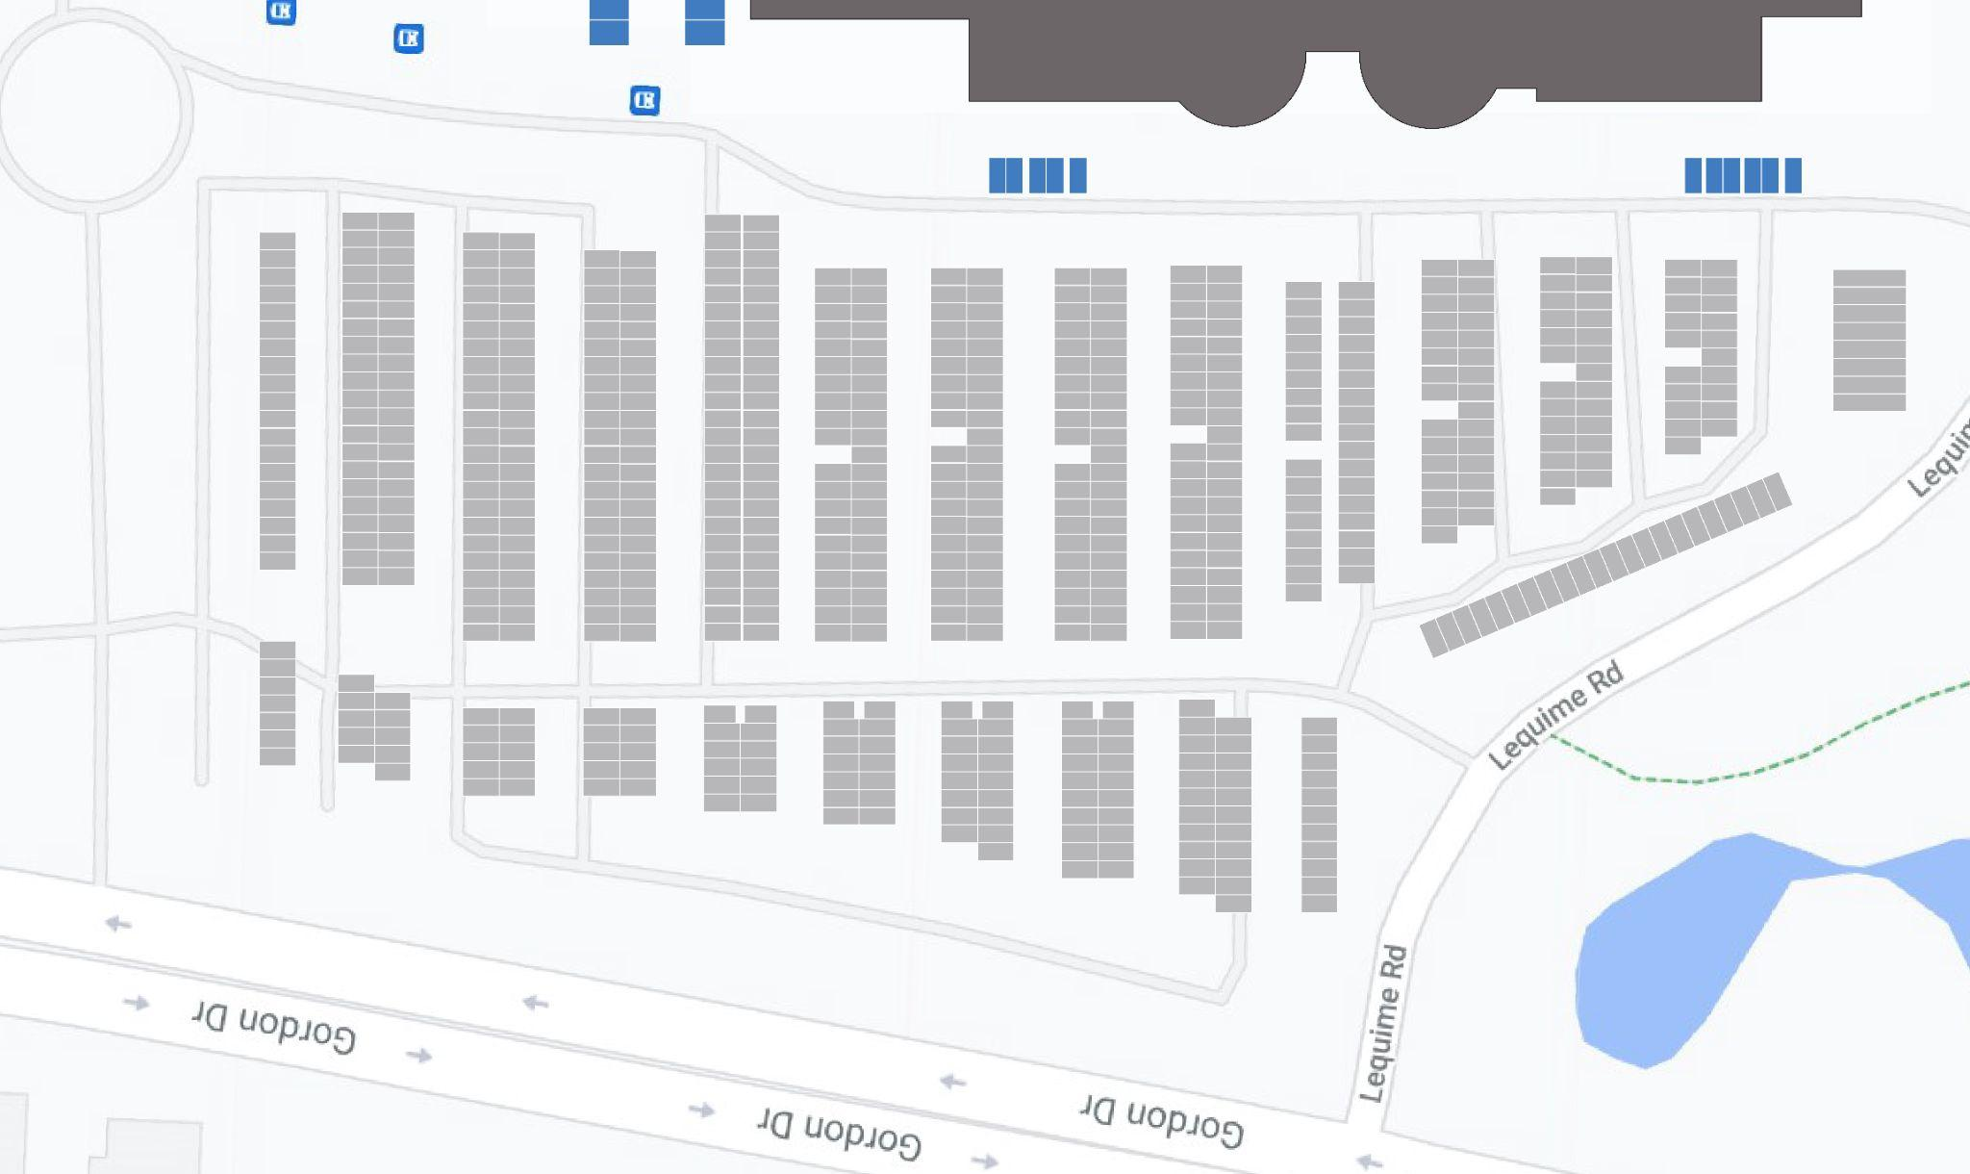

Event Setup / Teardown  - CNC has five (5) 12’ wide Loading Bays, two (2) double-door fire exits, and one (1) single-door fire exit  - During setup, Exhibitors will utilize the disabled parking stalls on the North side of the building on a first come first served basis  - Exhibitors are responsible for unloading their vehicles in a timely manner and transporting them to the appropriate locations  - After an Exhibitor has ‘loaded-in’ and been shown their respective space, they will be asked to move their vehicle (prior to beginning setup) so that the next Exhibitor can begin unloading their vehicle(s)  - No Exhibitor will be allowed to remain parked in this area (during this time), whether they have disabled parking permits or not  - During teardown, parking in this area will be a first-ready, first-served basis  - Exhibitors who are completely packed and ready for ‘load-up’ will be given access to a loading bay first | 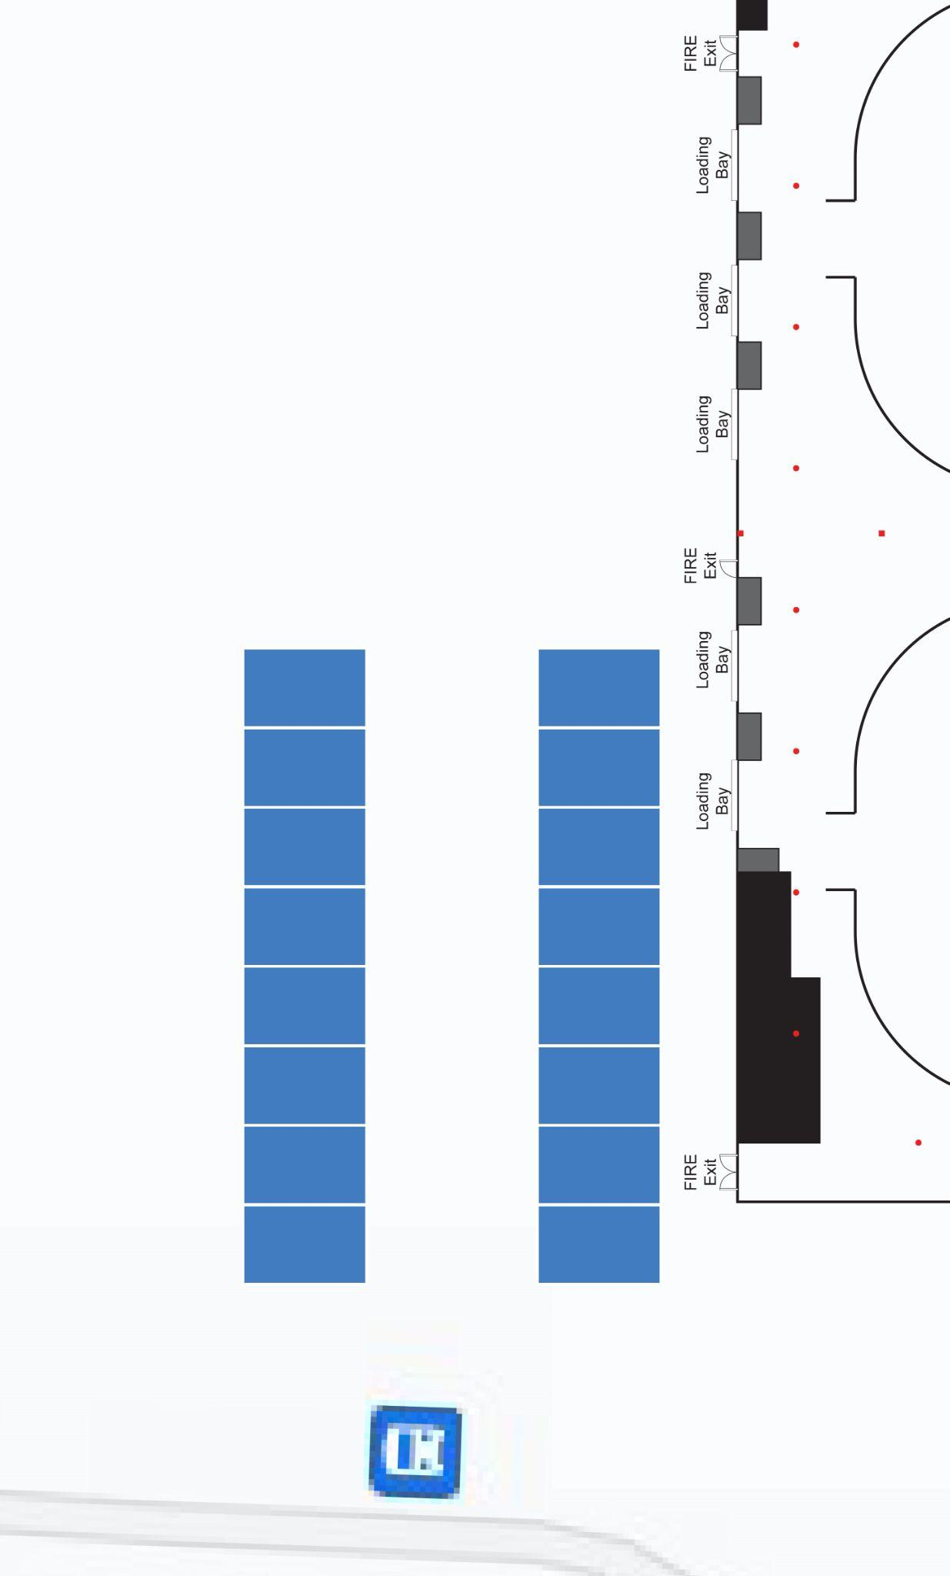

Food Vendors  - Potentially Food Vendors will be parked on the walkway in front of the Capital News Centre (Final approval of food vendors still to be determined)  - Food Vendors food will be welcome inside the CNC lobby / sitting area  - All food will be welcome in the venue space on the walkways surrounding the Vendor Field and the Event Field, but not on the turfed fields | 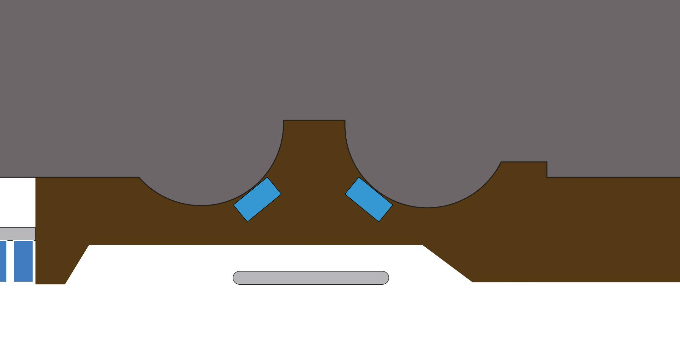
Washrooms  - Washroom access is just outside of the Venue Entrance, in the Capital News Centre lobby  - Exclusive Exit and Instant Access Entrances are available specifically for people with passes already, making travel between the lobby and venue space a non-issue  - Cosplay Repair / Change rooms that are located in the venue space each have a single washroom available for the general public | 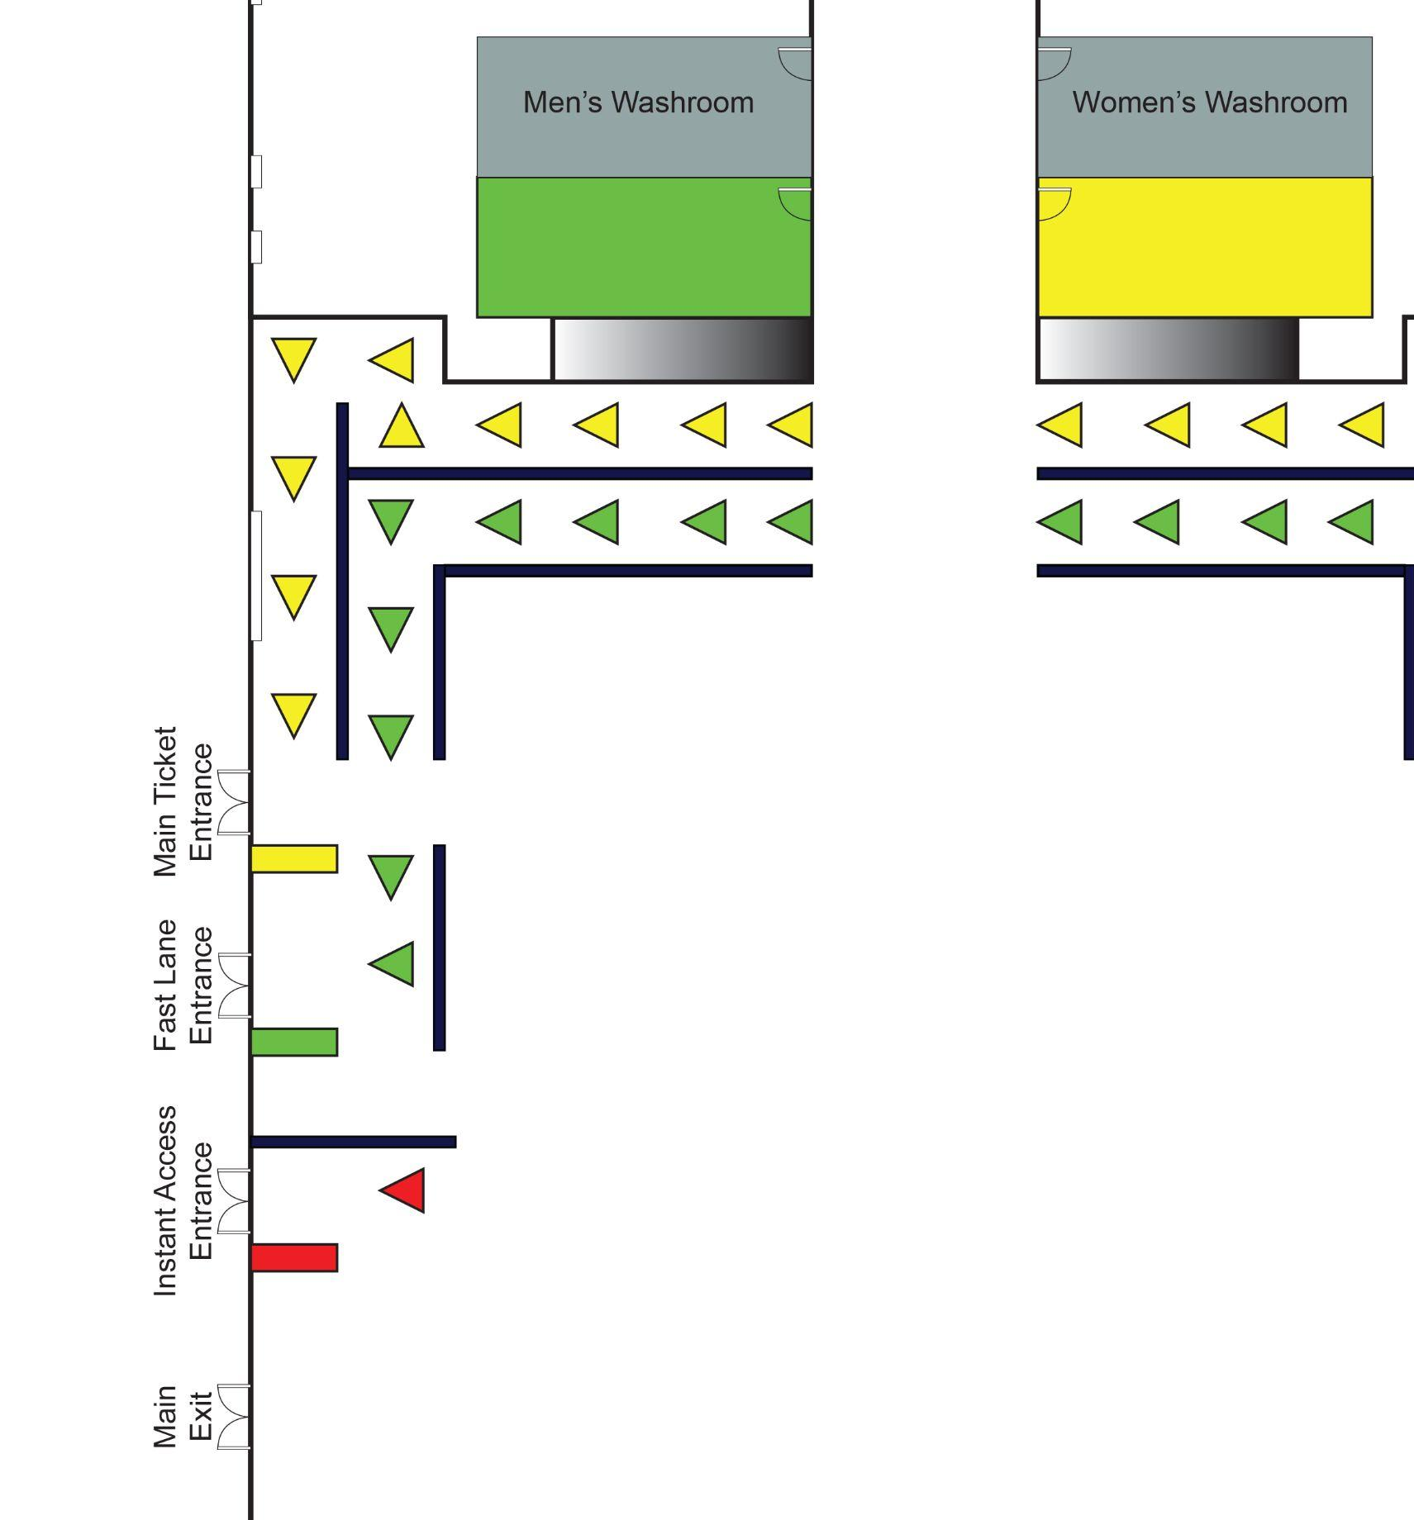

- Venue Space Layout
The following map shows the layout of the main Venue Space. The map represents a ‘Full Capacity’ layout. All current regulations, future changes and up to date layouts can be found at www.kelownacomicon.com/post/2022COVID Please note, the map is subject to change.
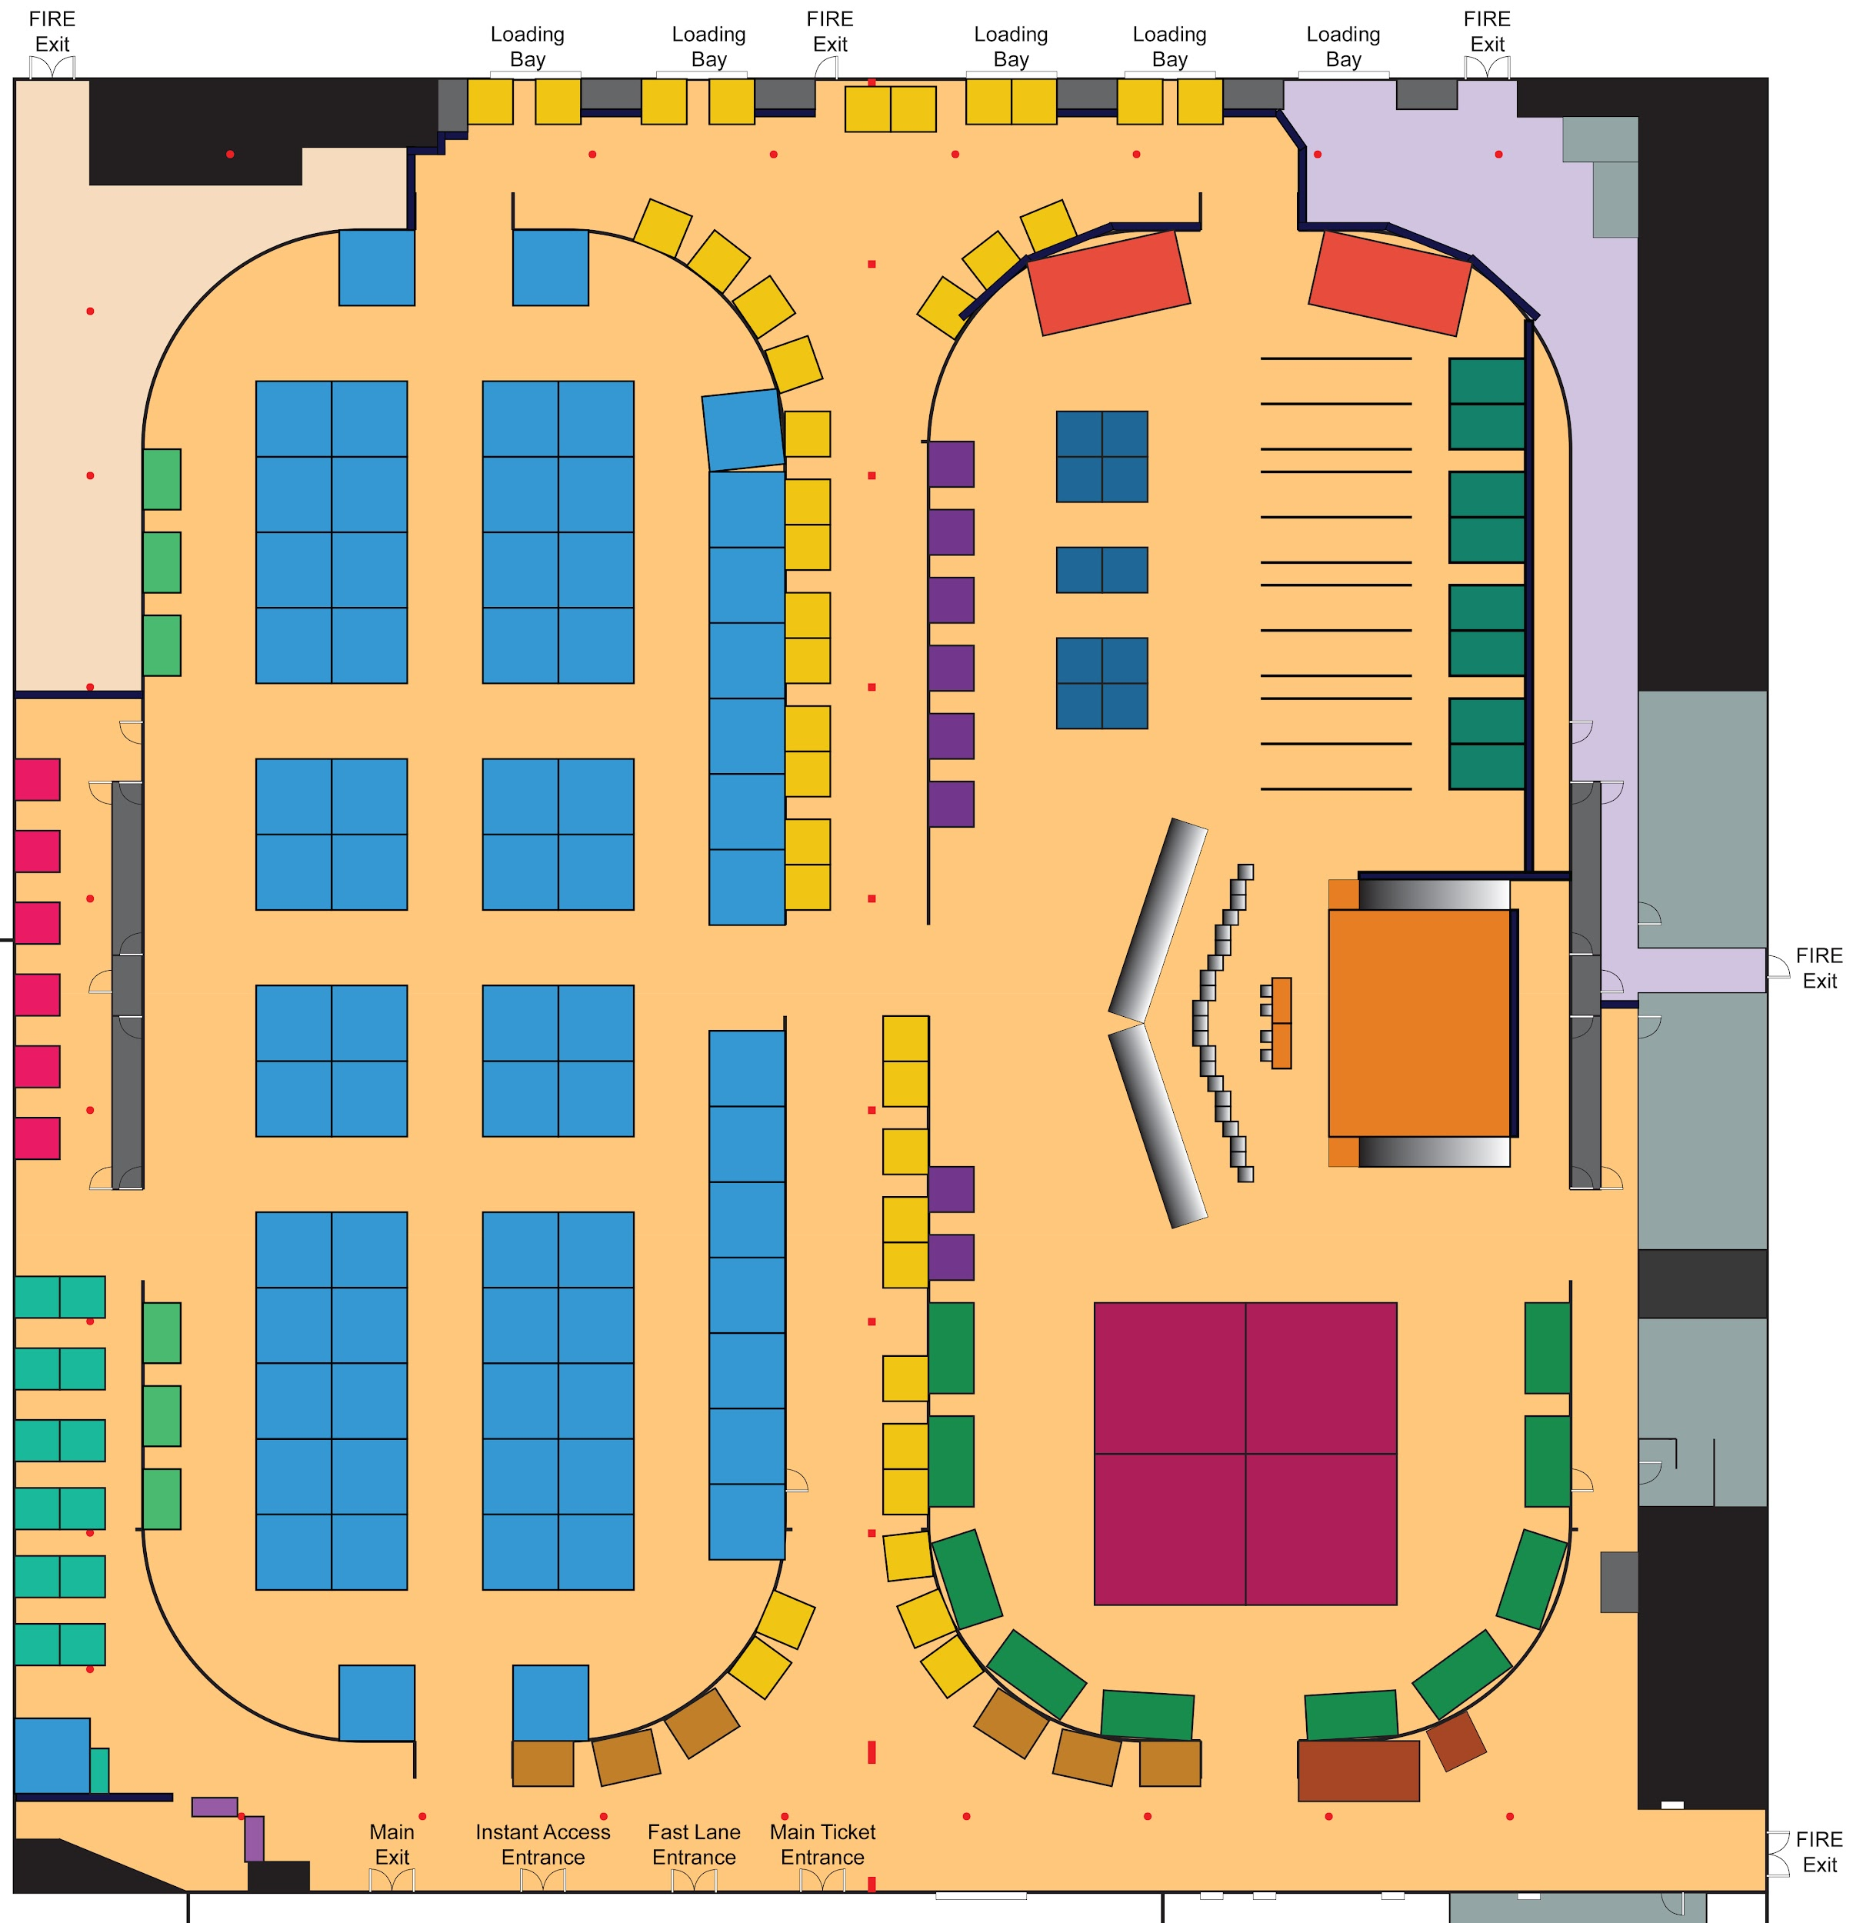
Venue Space Layout Legend
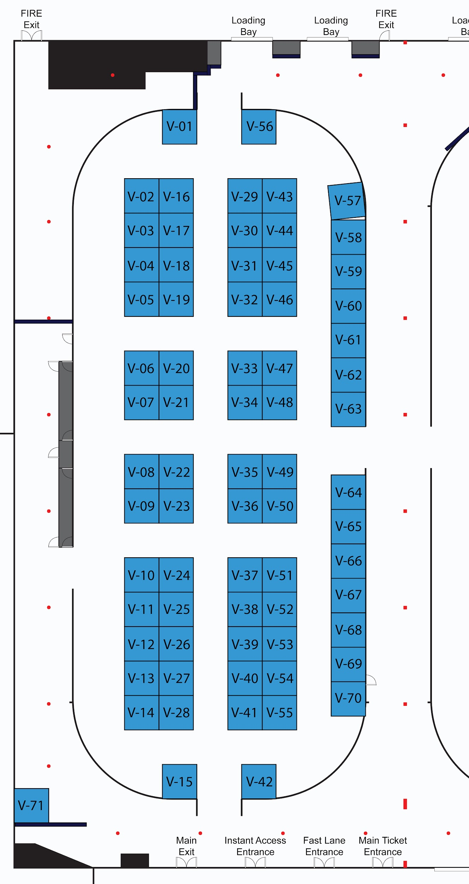 | Exhibitor Booth(s) Location Codes  - Exhibitor Spaces can be specifically requested in the Exhibitor Application.  - Selecting Exhibitor Space(s) does not guarantee in any way, the booth-location chosen.  - KCC takes preferences into consideration along with neighbouring exhibitors.  - In the event a chosen location is already occupied, KCC will endeavour to assist in selecting another option.

- Exhibitor Food

The Capital News Centre’s usual policy for food in regards to our Venue Space is that no food or drink, except water, is allowed on the turfed fields at any time for any reason. In order to address concerns about food in the venue space from our Exhibitors, the CNC has agreed to a compromise (on a trial basis) and KCC is arranging the following in order to better serve our Exhibitors:

- Food must be consumed by Exhibitors in the main food court, concrete floor areas or the designated Exhibitor eating area. Eating or drinking anything other than water on the turfed fields is not permitted.
- Report any and all spills to the KCC staff immediately in order to be cleaned up accordingly.
- A designated Exhibitor Eating area on the concrete floor will be provided along the side of the Vendor area to allow all exhibitor’s a quiet space to eat.
Food Menu
- KCC will be offering a Hot Dog, chips & drink pack for our Exhibitors for a fee and will be delivered to by a KCC volunteer at pre-arranged times. More details will be provided closer to the event. You are more than welcome to let us know at any time if you are interested in ordering.
- The Hot Dog Pack will only be available to Exhibitors, Guests, and KCC staff.
- KCC staff will be in charge of taking orders and delivering food to the Exhibitors.
- Menu will only be available at specifically designated times (TBD)
- Prices will be listed closer to the event and orders are to be paid by the Exhibitors upon delivery.

- Attendance / Traffic

KCC at full capacity will be expecting roughly 440 members of Exhibitors, KCC Staff, and Guests. Typical of KCC’s historical attendance, we can expect a minimum average paid-attendance of 1,300 people per day. Totalling an approximate of 1,740 per day for Kelowna ComiCon. For this event we have secured a means to ensure a proper attendance and demographic information for our Exhibitors and Staff in the future.
Ticket Lines  - KCC will have three (3) major entrances to the venue: Main, ‘Fast Lane’, and ‘Instant Access’  - Main Ticket Entrance will be used for those who need to buy their passes at the event  - ‘Fast Lane’ Entrance will give priority to Premium, and VIP ticket holders, but will also allow admittance to pre-purchased tickets  - ‘Instant Access’ Entrance will be for anyone who already has their pass  - KCC staff will be used to accelerate traffic flow by performing prop checks in-line and at the entrance-tables  - Props that do not pass checks will be asked to be stored outside of the venue or will be turned into the KCC Coat Check to be held until pickup by attendee (at the cost of the attendee) | 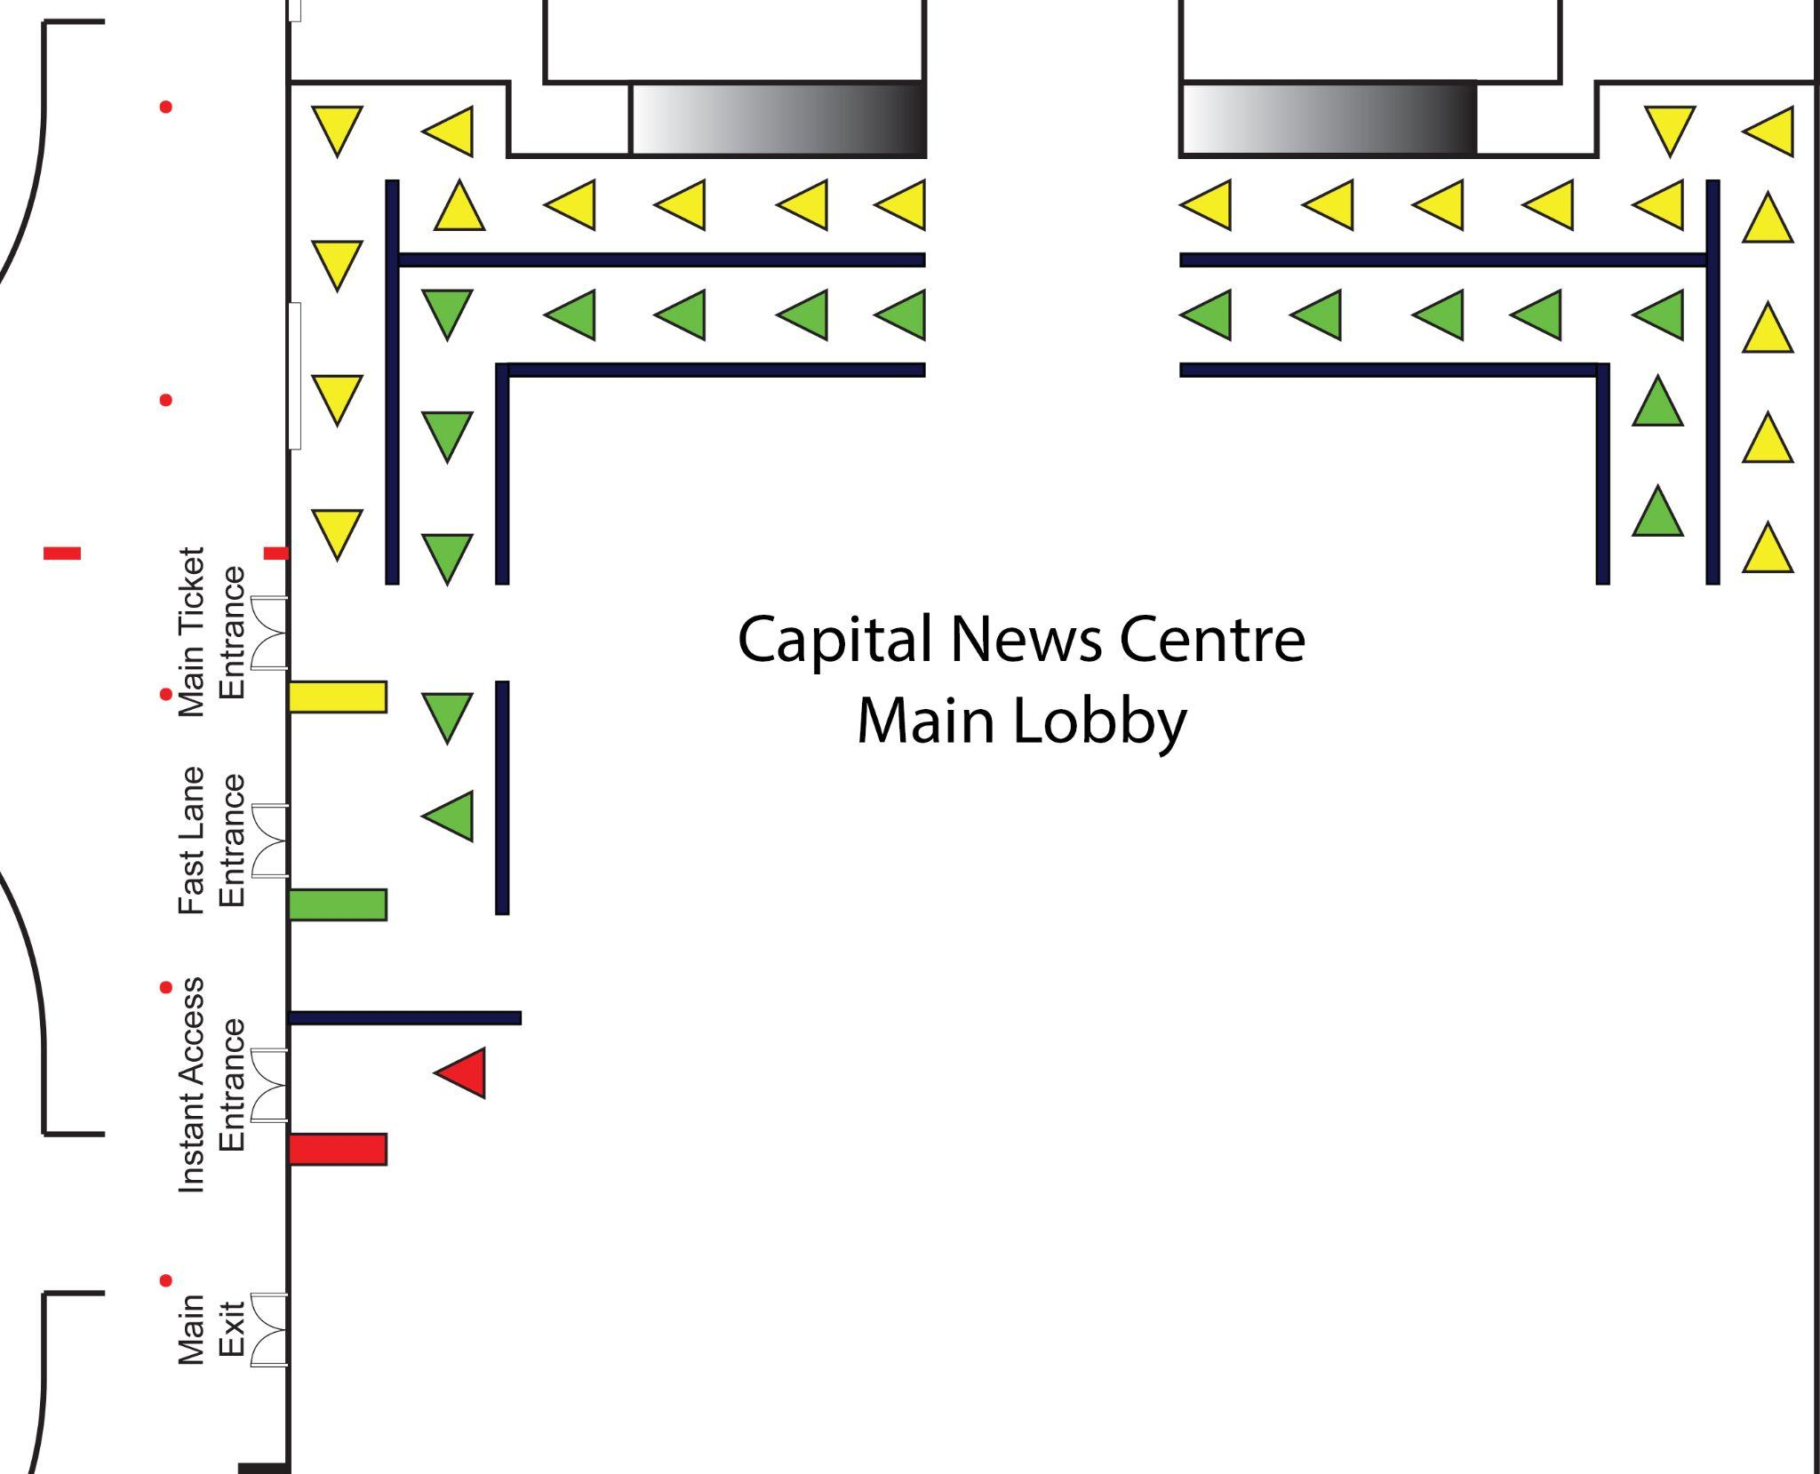
Exhibitor Access During ‘Open’
- Exhibitors will have private access to and from the Venue through the North-East Fire Exit (upper left exit in image)
- Exhibitors who need to bring materials into their booth during ‘Open’ can use a cart or dolly in the draped off areas and outside the Venue. Please transfer materials by hand in ‘public access’ areas

- Exhibitor Application

Exhibitor Applications are available online at www.kelownacomicon.com/exhibitor. Exhibitor Applications will be available until June 30th, 2023, at 11:59pm PST. Any applications received after this time period may be considered for a waitlist option in the event of cancellation from another Exhibitor.

An Exhibitor Booth will only be held once an application is processed. Exhibitor Applications will be considered processed after full payment for the Exhibitor Booth has been received by KCC.

- Exhibitor Contract

Exhibitor Contract

KCC and the Exhibitor, in consideration of the mutual covenants set forth in this Contract and for other good and valuable consideration, the receipt and sufficiency of which is hereby acknowledged, agree as follows:

- Definitions

  - “KCC” means the Kelowna ComiCon, its Staff, agents, and representatives.
  - “Contract” means the whole agreement between the parties which is this Exhibitor contract.
  - "Event" means the pop-culture event entitled Kelowna ComiCon.
  - “Exhibitor” means collectively the individual, group, or company that applied for Exhibitor Booth as set out in this contract and each of the Exhibitor’s officers, directors, employees, and representatives as applicable.
  - “Artist” means collectively the individual, group, or company that applied for Artist Alley located Exhibitor Booth(s) and any assistants, helpers, volunteers, or staff of the Artist shall be referred to as “Assistant”. Artist(s) are also considered Exhibitor(s).
  - “Event Space” means the area that has been designated for sale of goods and services.
  - “Exhibitor Booth” means the area within the Event Space that has been allocated to the Exhibitor.
  - “Artist Alley” refers to location-specific Exhibitor Booths.
  - “Venue” means the facilities or buildings hosting the Event, in this regard, the Capital News Centre.
  - “Pass” is proof of admission used by the Event. Typically presented as a wristband, badge, or lanyard.
  - “Guest” refers to the artists, cosplayers, and celebrities that have been invited by KCC to attend the Event on behalf of KCC.
  - “Cosplay” is the act of dressing up and/or roleplaying as a fictional character.
  - “Attendee” is everyone who is participating in the Event who has been issued a valid Pass.
  - “Prop” refers to an accessory of cosplay that is generally viewed as a replica of a weapon.
  - “Unlicensed” indicates unofficial goods and services. Including but not limited to costumes, accessories, artwork, and media that is created without the express permission from the trademark owner or authorized representative.
  - “Bootleg” indicates unofficial goods and services that are reproduced works and/or replications of licensed products. Commonly referred to as counterfeit goods.
  - “Proxy Selling” refers to the selling of another Artist’s work with their permission.

- Exhibitor License

  - Subject to the other terms and conditions of the Contract, KCC grants the Exhibitor a non-exclusive license to use and occupy the Exhibitor's Space at the Event Space during the Event. This license is terminable at will by KCC.
  - Unless otherwise specified, any violations of the terms and conditions of this Contract by the Exhibitor may result in, at the absolute discretion of KCC, immediate termination of this license and expulsion from the Event.
  - In the event of the expulsion of an Exhibitor, the Exhibitor shall be solely responsible for any outstanding fees or costs, including costs incurred by KCC to enforce the terms and conditions of this Contract, including any legal fees incurred by KCC on a solicitor-client, full indemnity basis.
  - The Exhibitor agrees to be present at and operating their Exhibitor Booth for the hours of public access to the Event Space.
  - Tardiness, behaviour, and contract compliance may impact the Exhibitor selection process at future events.

- License and Regulations

  - Subject to the other terms and conditions of the Contract, KCC grants the Exhibitor a non-exclusive license to use and occupy a booth(s) in the Event Space during the Event.
  - The Exhibitor shall be solely responsible for obtaining any licenses, permits, or approvals required by local, provincial and federal laws (i.e. business license, GST number, etc.), applicable to their activity at the Event, as well as for paying all taxes, license fees, fines, or any charges incurred with respect to the same.
  - The Exhibitor may be required to provide any of the above information upon request of KCC.

- Exhibitor’s Space

  - An Exhibitor Booth at the Event shall be assigned at the absolute discretion of KCC.
  - KCC may change the floor plan or require an Exhibitor to relocate prior to or during the Event.
  - During setup and teardown times, or while heavy machinery is in operation, those under 18 years of age are not allowed in the Event Space area.
  - Special exceptions may only be made if submitted in writing to KCC as part of the Exhibitor Application.
  - Only the KCC Administration, Capital News Centre General Manager, or the Fire Marshall can open or close the Event Space for any purpose at any time.
  - At no point can the Exhibitor, or their property, block or impede access to any fire equipment, entrances, exits, or aisles.
  - A maximum of two (2) people (per booth) are allowed to operate an Exhibitor Booth in the Artist Alley, with a maximum of two (2) chairs (per booth).
  - The Exhibitor may arrange any displays, chairs, tables, and merchandise in any manner within their Exhibitor Booth provided that the Exhibitor does not cause any damage to the equipment or Venue, and ensure all applicable fire and safety regulations are maintained.
  - Any displays, chairs, tables, and merchandise must be located only within the Exhibitor Booth prior to the opening of the Event Space to the public.
  - All displays over 8’ in height may be required to be inspected and approved by KCC and their compliance.
  - Notwithstanding the above, KCC, at its absolute discretion, may require changes to the Exhibitor’s displays, chairs, tables, and merchandise.
  - The Exhibitor may not display anything that is deemed by KCC to be offensive or inappropriate. KCC may require, at any time, for anything to be removed or censored from the Exhibitor Booth.
  - The Exhibitor agrees to keep their Exhibitor Booth clean and agrees not to nail, screw, or otherwise affix anything to the Event Space or the equipment provided in a way that may damage the same.
  - Electricity will be available within specified areas of the Event Space at an additional charge. Wifi will be provided at no extra charge.
  - Unauthorized cabling, piping, or tampering with existing cable and power lines and facilities are prohibited.
  - Any costs incurred by KCC for clean-up or damages to the Event Space caused by the Exhibitor will be charged to the Exhibitor.

- Exhibitor Registration

  - Exhibitor Booth will only be held once an application is processed.
  - Exhibitor applications will be considered processed after full payment for the Exhibitor Booth has been received by KCC.
  - The Legal Name on your registration MUST MATCH the name on your government-issued ID for sign-in.

- Promotional Rights

  - The Exhibitor grants KCC the right to list their business name and/or alias in Event printed and electronic media.
  - Should the Exhibitor not provide a business or alias name, the Exhibitor grants KCC the right to use their Legal Name.
  - KCC grants the Exhibitor the right to list the Event in their printed and electronic media.
  - The Exhibitor is not permitted to use KCC mascot(s), logo(s), or other intellectual properties unless separate written permission is given to the Exhibitor by KCC.
  - KCC reserves the right to use any photo or video featuring the Exhibitor and/or their Exhibitor Booth taken during the Event for promotional purposes.

- Payment, Refund and Cancellations

  - KCC's preferred method of payment is via online payment as outlined on our digital invoices. A payment link will be sent upon successful exhibitor approval. The instructions on providing payment will be listed at the link provided to the Exhibitor.
  - All prices are in CAD (Canadian dollars), and KCC will only accept Canadian funds. Cash payments can be made in person with the Event’s treasurer by appointment. All payments should be addressed to the "Kelowna ComiCon". Exhibitor is responsible for repayment of any NSF fees subjected to KCC by arrangements with the Exhibitor.
  - Full payment on the Exhibitor Booth is due by May 31, 2023. Exhibitors will be given a two (2) week notice if full payment has not been received by this date. Failure to make payment of any outstanding balance during this time will be treated as a cancellation from the Exhibitor, and the Exhibitor forfeits all sums submitted.
  - KCC requires a written cancellation notice no later than June 30, 2023 for a full refund (less administrative fees).
  - Cancellation notices received between June 30, 2023 and July 31, 2023 will result in a refund of 50% of the total balance.
  - Any cancellation after July 31, 2023 forfeits all sums submitted to KCC.
  - Applicants who apply or are confirmed on May 31, 2023 or later must pay in full within 2 weeks of receiving confirmation of their Exhibitor Booth by the Event, and no later than August 18, 2023, whichever comes first. Payments after this date, under these circumstances are non-refundable.
  - Notwithstanding the other terms and conditions of this Contract, the Event may, at its absolute discretion, approve a refund if there are extraordinary circumstances which are accepted by the Event.
  - Any Exhibitor Booth not claimed by the commencement of the Event on August 19, 2023 at 7am PST may be resold at the absolute discretion of KCC.
  - Exhibitor agrees to release and otherwise hold KCC harmless for any foreseen or unforeseen losses, damages, or claims incurred by the Exhibitor as a result of unclaimed or cancelled Exhibitor Booth.

- Subletting and/or Assignments of Exhibitor Booth

  - The Exhibitor Booth is for use by the Exhibitor only and the Exhibitor may not assign or otherwise transfer its license to the Exhibitor Booth unless the Exhibitor receives written approval from the Event.

- Parking

  - Processed applicants will be issued a separate parking pass with details on appropriate Exhibitor parking locations.
  - Exhibitors will receive their Passes and parking pass upon signing in with KCC during load in.
  - Parking passes are used to prevent an Exhibitor’s vehicle(s) being ticketed and towed at the owner's expense and must be displayed visibly on the vehicle dashboard.
  - Parking passes are valid overnight, and allow Exhibitors to remain parked in the Venue parking lot at their own risk.
  - Neither KCC or the Venue accept responsibility or liability whatsoever for any damages, loss, theft, harm or injury to the Exhibitor’s vehicle(s).
  - KCC and the Venue may require an Exhibitor to relocate their vehicle(s) prior to or during the Event.

- Exhibitor Passes

  - Each Exhibitor shall be issued Exhibitor Passes as summarized in the pricing fees.
  - Exhibitor's Representatives must wear their Exhibitor Passes during the duration of the Event including setup, closing(s), and tear down periods.
  - Only individuals with an Exhibitor Pass will be allowed to act in any function as a representative for the Exhibitor.
  - Exhibitor Passes may not be sold, loaned, or otherwise transferred or assigned to any individual who is not an Exhibitor's representative.
  - Exhibitor Passes may be shared among Exhibitor’s Representatives, but no more than one (1) individual may claim the Exhibitor Pass at any given time.
  - The Exhibitor Pass provides an equivalent access level to an Event Pass.

- Security and Crowd Control

  - KCC will provide a licensed Security service. Nevertheless, the Exhibitor is fully responsible for all Exhibitor property and the Exhibitor must take whatever steps are reasonably necessary for the Exhibitor to protect their property.
  - KCC accepts no responsibility or liability whatsoever for any damages, loss, theft, harm or injury to the Exhibitor’s property.
  - All property of the Exhibitor is understood to remain in the Exhibitor’s possession, care and control at all times.
  - KCC is not a bailee of any property of the Exhibitor whatsoever.
  - Should any theft or damage occur within your Exhibitor Booth, please report it to the Event Staff in charge of your area.

- Storage

  - KCC does not provide storage for Exhibitors and an Exhibitor must not store their belongings in any public space.

- Food and Beverage

  - Unless requested in writing by May 1, 2023 and approved by The Event, The Exhibitor shall not provide any food, beverages or consumable items, for sale or otherwise, within the Event Space, the Event grounds, or any other facilities used by the Event.
  - If you wish to sell food and/or beverages, please complete a food vendor application.
  - No food or beverages except water are allowed on the Turfed Field areas for sale or personal use.

- Atmosphere and Noise Policy

  - While the Exhibitor may play audio and video devices, Exhibitors may only do so at volumes which do not disrupt other Exhibitors or Event attendees.
  - KCC, at its absolute discretion, may require an Exhibitor to lower the volume of, or otherwise turn off, any Exhibitor audio and video device.
  - Exhibitors will not engage in activities that the KCC deems disruptive or inappropriate to other exhibitors, staff or attendees.

- Sales from Outside Designated Area

  - Exhibitors are prohibited from selling goods or services outside of the Event Space or other areas which may be designated for the same by KCC.

- Restricted Content

  - Adult or sexually explicit material may only be sold, exchanged, or donated to individuals who have confirmed they are at least 18 years of age by showing valid government-issued photo ID.
  - Content that could be deemed offensive or inappropriate must be censored and have an acceptable effort made to prevent content or merchandise from being accessible to minors.
  - Any nudity or foul language must be censored appropriately.
  - All fan made comics (such as Doujinshi) must clearly indicate target age, subject matter, and copyright information.
  - If there is a dispute of content or acceptable level of censorship, the Event will determine what is considered offensive or inappropriate.
  - An Exhibitor must be 18 years of age or older in order to sell restricted content.

- Authorized, Unlicensed or Bootleg Goods

  - Products sold in the Artist Alley must be, and/or contain, the intellectual property of the Artist the Exhibitor Booth is registered to.
  - No Proxy Selling will be allowed without the express written permission of the intellectual property owner prior to the Event. The Exhibitor must, upon demand of KCC, deliver to KCC acceptable evidence of permission prior to the Event.
  - Exhibitors are forbidden from selling replications or artwork and merchandise that do not have, and/or contain, the intellectual property of the Exhibitor (e.g. officially licensed goods/artwork) and depicting trademarked or copyrighted logos in any form (e.g. written, drawn).
  - KCC does not authorize the sale of any Unlicensed goods and services.
  - KCC may request the Exhibitor to furnish Unlicensed goods and services with clearly unambiguous labeling or signage depicting such details.
  - KCC recognizes that some Unlicensed goods and services may fall under the rights of fair dealing in Canada and are protected by the Copyright Act, R.S.C., 1985, c. C-42.
  - The Exhibitor shall be solely responsible for ensuring that the sale of their Unlicensed goods and services are permitted under the above Act.
  - KCC does not authorize or otherwise permit the sale of any Bootleg goods or services.
  - KCC may terminate the license of an Exhibitor if KCC reasonably believes that the Exhibitor is offering for sale Bootleg goods and services.
  - Bootleg goods and services are federally criminal under the Combating Counterfeit Products Act, S.C. 2014, c. 32.
  - Compliance of these terms may impact the Exhibitor selection process at future events.

- Weapons & Prop Sales Policy

  - The Exhibitor may sell non-metal training paraphernalia (wooden training swords, shinais, etc.) and props, in the Exhibitor Booth only.
  - KCC may, at its absolute discretion, designate an item as a weapon for the purposes of this Contract.
  - Any training paraphernalia must be sold only to patrons over the age of 18 who must show valid government issued photo ID prior to purchasing (the responsibility of the Exhibitor).
  - All training paraphernalia purchased must be placed in the original packaging and tagged with the Exhibitor’s name before being given to the buyer.
  - All training paraphernalia that do not meet the requirements of KCC’s general policies must be immediately removed from the Event grounds once given to the buyer by the Exhibitor and it is the responsibility of the Exhibitor to inform the buyer of this.
  - The sale of any props by any Exhibitor must comply with the Event’s Prop Policy.
  - KCC may, at its absolute discretion, restrict the sale of any prop.
  - The sale of any metal or composite weapons by any Exhibitor is prohibited within the Event Space, Event grounds, or other facilities used by Event.
  - If the Exhibitor would like a ruling on a specific item, please contact the Exhibitor Team.

- Receipts

  - The Exhibitor must provide receipts for customers upon request.
  - If the Exhibitor has a no refund and/or no exchanges policy, the Exhibitor must prominently display a notice of the same.

- Shipping and Deliveries

  - KCC will not accept or otherwise receive a delivery of any Exhibitor property being shipped to the Venue or KCC.
  - Any shipping and delivery requirements that the Exhibitor may have are to be arranged solely by the Exhibitor.
  - If any charges, fees, or losses are incurred by KCC due to Exhibitor shipments or deliveries, these will be charged to the Exhibitor.

- Insurance

  - The Exhibitor must, at its own expense and without limiting its liabilities under this Contract, ensure that it maintains all required insurance in accordance with the Insurance Act, RSBC 2012, c 1.
  - The Exhibitor must also carry general liability insurance in an amount of not less than $2,000,000 CAD per occurrence inclusive of bodily injury, death, and property damage, including the loss of use thereof, which is caused by any act or omission of the Exhibitor, the Exhibitor’s employees, subcontractors or agents, or which could otherwise occur as a result of the Exhibitor’s participation at the Event.
  - The Exhibitor must, upon demand of KCC, deliver to KCC acceptable evidence of insurance, in the form of a detailed certificate of insurance prior to the Event.

- General Policies

  - The Exhibitor agrees to follow and be bound by the Event’s General Policies, which may be amended from time to time.
  - These policies shall be made available upon request of the Exhibitor, and will be included in the Exhibitor package.

- Limitation of Liability

  - The Exhibitor agrees that KCC will not be liable under any circumstances for any loss, injury, damage, or other expenses that may arise out of any act or omission by the Exhibitor.
  - Any damages or charges imposed for violations of any applicable laws or regulations by the Exhibitor are the sole responsibility of the Exhibitor.
  - KCC makes no guarantees or representations to the number of attendees at the Event.
  - The Exhibitor assumes full liability for the actions or omissions of its agents, employees, or independent contractors to any attendee.
  - KCC has the full power to make amendments to this Contract by providing notice to Exhibitor but only to the extent those changes become necessary by order, demand, or request of the Venue or any other governing body including, but not limited to the Government of Canada, the Government of British Columbia and the City of Kelowna.
    - Such further rules and regulations as well shall be considered necessary and proper.
    - If Exhibitor does not consent to such changes, Exhibitor may choose to terminate this Contract in writing.
    - Should this Contract be terminated in this matter, the Exhibitor will be entitled to full refund without any deductions on the part of KCC.

- Statutory Compliance

  - The Exhibitor shall abide by and observe all federal, provincial, and local laws, codes, ordinances, rules and regulations and all rules and regulations of the Venue.
  - The Exhibitor will pay, when due, all taxes, rates, duties, assessments and license fees that may be levied, rated, charged or assessed upon the Exhibitor by virtue of Exhibitor’s participation at the Event.

- Violation of Contract

  - Violation(s) of this Contract may result in warning or expulsion from the Event.
  - KCC will make all determinations in regards to what violations warrant a warning or expulsion.
  - Upon Exhibitor expulsion from the Event, the license is terminated and no refunds will be issued.
  - Exhibitors who are expelled from the event will be subject to a 1-year suspension from the Event at KCC’s discretion.

- General Terms

  - Each party shall perform the acts, execute and deliver the writings, and give the assurances necessary to give full effect to this Contract.
  - This Contract contains the entire agreement of the parties concerning the subject matter of this Contract and no other understandings or agreements, verbal or otherwise, exist between the parties.
    - No provision of this contract shall be deemed to be waived by either party unless such waiver is in writing.
    - Any waiver of any default committed by either of the parties hereto in the observance or performance of this contract shall not extend or be deemed to extend to or affect any other default.
  - This Contract may only be amended in writing that is acknowledged and agreed upon by both parties except as otherwise contemplated herein.
  - No party shall assign, sell or otherwise transfer any of its rights or obligations under this Contract without the prior written approval of the other party.
  - In this Contract, words in the singular include the plural and words in the plural include the singular and any headings and capitalizations, except those specifically defined herein, are included for the purposes of readability only and do not impact the meaning of any part of this Contract.
  - The rights, remedies and privileges of KCC under this Contract are cumulative and any one or more may be exercised.
    - The rights of KCC shall not be deemed waived unless specifically stated in writing and signed by an authorized officer of KCC.
  - Time is of the essence in this Contract.
  - This Contract shall be governed by and construed in accordance with the laws of the province of British Columbia and the federal laws of Canada applicable therein without giving effect to the choice of laws provisions thereof and the Parties agree to irrevocably attorn to the jurisdiction of the courts of British Columbia and agree that any proceedings taken in respect of this Agreement shall be taken in such courts and in no other.
  - Should any provision of this Contract be illegal or unenforceable, it shall be considered separate and severable from this Contract, and the remaining provisions shall remain in force and be binding upon the parties hereto as though the said provision had never been included.
  - The Exhibitor represents that it has the power and authority to enter into this Contract.
  - The Exhibitor grants KCC permission to display the name of the Exhibitor in online and print publications relating to the Event Space and the Event. KCC is under no obligation to make use of this permission.
  - Contract violations may result in warnings, forfeiture of Exhibitor Booth, removal from the Event, up to possible banning from future events based on history and severity of the violation as determined by the Event.

